**ASSIGNMENT – 11**

**ON: CREATING VIEWS**

**Q1. Create a view called EMPLOYEES_VU based on the employee numbers, employee names, and department numbers from the EMPLOYEES table. Change the heading for the employee name to EMPLOYEE.**

Ans1.

CREATE OR REPLACE VIEW EMPLOYEES_VU AS

SELECT EMPLOYEE_ID, LAST_NAME EMPLOYEE, DEPARTMENT_ID

FROM EMPLOYEES;

**Q2. Display the contents of the EMPLOYEES_VU view.**

|  |  |  |
| --- | --- | --- |
| **EMPLOYEE_ID** | **EMPLOYEE** | **DEPARTMENT_ID** |
| **100** | **King** | **90** |
| **101** | **Kochhar** | **90** |
| **102** | **De Haan** | **90** |
| **103** | **Hunold** | **60** |
| **104** | **Ernst** | **60** |
| **107** | **Lorentz** | **50** |
|  |  |  |
| **206** | **Gietz** | **110** |

**20 rows selected.**

Ans2.

SELECT * FROM EMPLOYEES_VU;

**Verification table-**

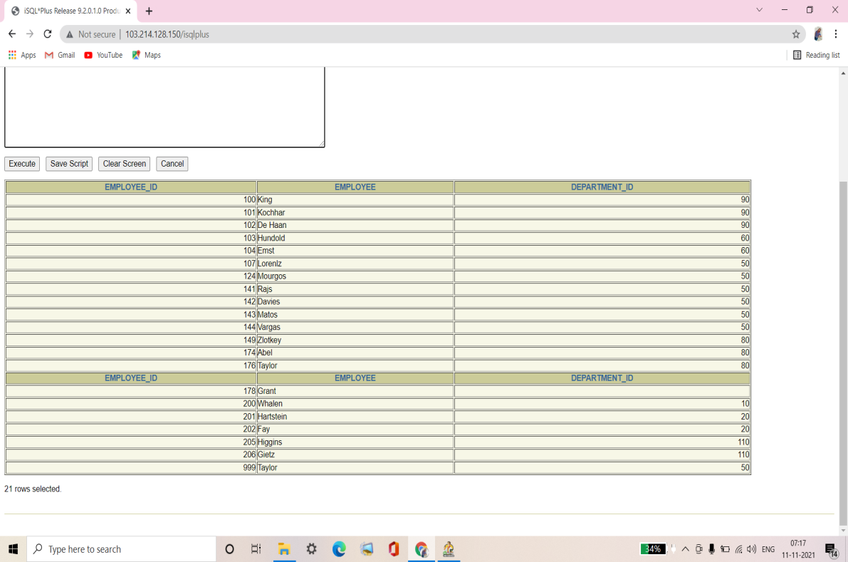

**Q3. Select the view name and text from the USER_VIEWS data dictionary view.**

**Note: Another view already exists. The EMP_DETAILS_VIEW was created as part of your schema.**

**Note: To see more contents of a long column, use the iSQL*Plus command SET LONG n, where n is the value of the number of characters of the LONG column that you want to see.**

|  |  |
| --- | --- |
| **VIEW_NAME** | **TEXT** |
| **EMPLOYEES_VU** | **SELECT employee_id, last_name employee, department_id FROM employees** |
| **EMP_DETAILS_VIEW** | **SELECT e.employee_id, e.job_id, e.manager_id , e.department_id, d.location_id, l.country_id, e.first_name, e.last_name, e.salary, e.commission_pct, d.department_name, j.job_title, l.city, l.state_province, c.country_name, r.region_name FROM employees e, departments d , jobs j, locations l, countries c, regions r WHERE e.department_id = d.department_id AND d.loaction_id = l.location_id AND l.country_id = c. country_id AND c.region_id = r.region_id AND j.job_id = e.job_id WITH READ ONLY** |

Ans3.

SET LONG 1000

SELECT VIEW_NAME, TEXT

FROM USER_VIEWS;

**Verification table-**

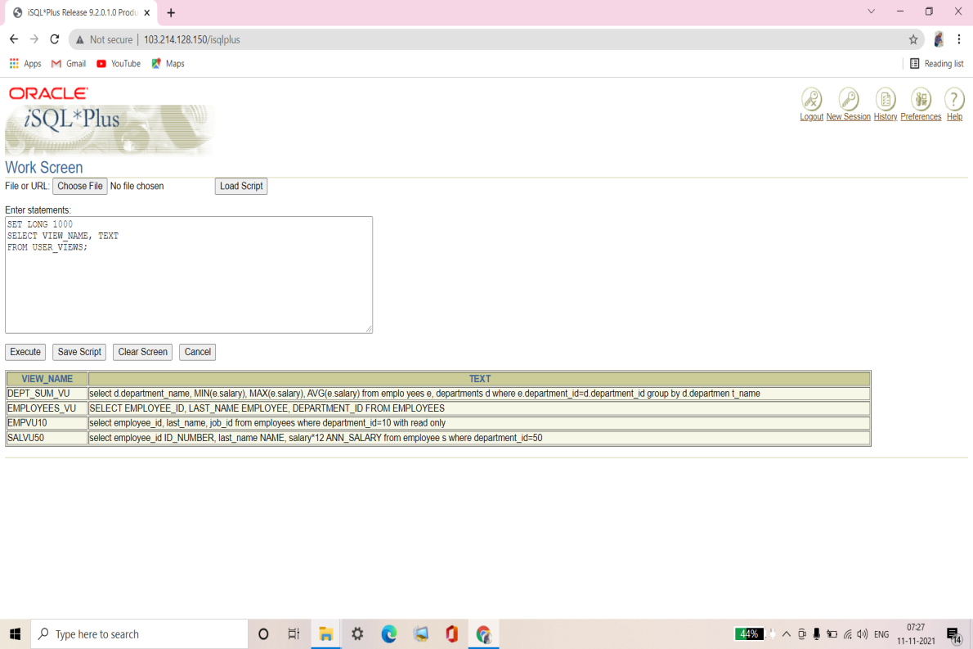

**Q4. Using your EMPLOYEES_VU view, enter a query to display all employee names and department numbers.**

|  |  |
| --- | --- |
| **EMPLOYEE** | **DEPARTMENT_ID** |
| **King** | **90** |
| **Kochhar** | **90** |
| **De Haan** | **90** |
|  |  |
| **Gietz** | **110** |

**20 rows selected.**

Ans4.

SELECT EMPLOYEE, DEPARTMENT_ID

FROM EMPLOYEES_VU;

**Verification table-**

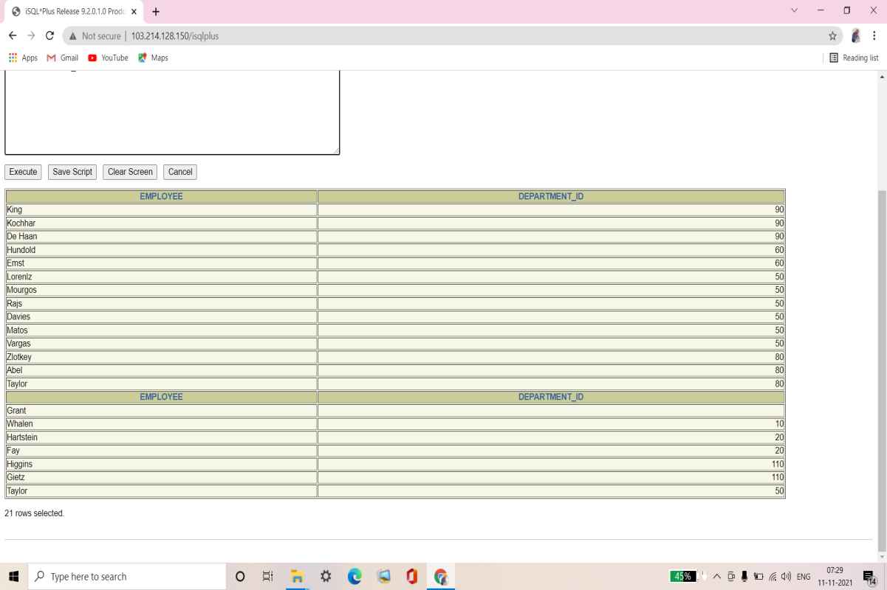

**Q5. Create a view named DEPT50 that contains the employee numbers, employee last names, and department numbers for all employees in department 50. Label the view columns EMPNO, EMPLOYEE, and DEPTNO. Don not follow an employee to be reassigned to another department through the view.**

Ans5.

CREATE OR REPLACE VIEW DEPT50 AS

SELECT EMPLOYEE_ID EMPNO, LAST_NAME EMPLOYEE, DEPARTMENT_ID DEPTNO

FROM EMPLOYEES

WHERE DEPARTMENT_ID=50

WITH CHECK OPTION CONSTRAINT EMP_DEPT_50;

**Q6. Display the structure and contents of the DEPT50 view.**

|  |  |  |
| --- | --- | --- |
| **Name** | **Null?** | **Type** |
| **EMPNO** | **NOT NULL** | **NUMBER(6)** |
| **EMPLOYEE** | **NOT NULL** | **VARCHAR2(25)** |
| **DEPTNO** |  | **NUMBER(4)** |

|  |  |  |
| --- | --- | --- |
| **EMPNO** | **EMPLOYEE** | **DEPTNO** |
| **124** | **Mourgos** | **50** |
| **141** | **Rajs** | **50** |
| **142** | **Davies** | **50** |
| **143** | **Matos** | **50** |
| **144** | **Vargas** | **50** |

Ans6.

DESCRIBE DEPT50;

SELECT * FROM DEPT50;

**Verification table-**

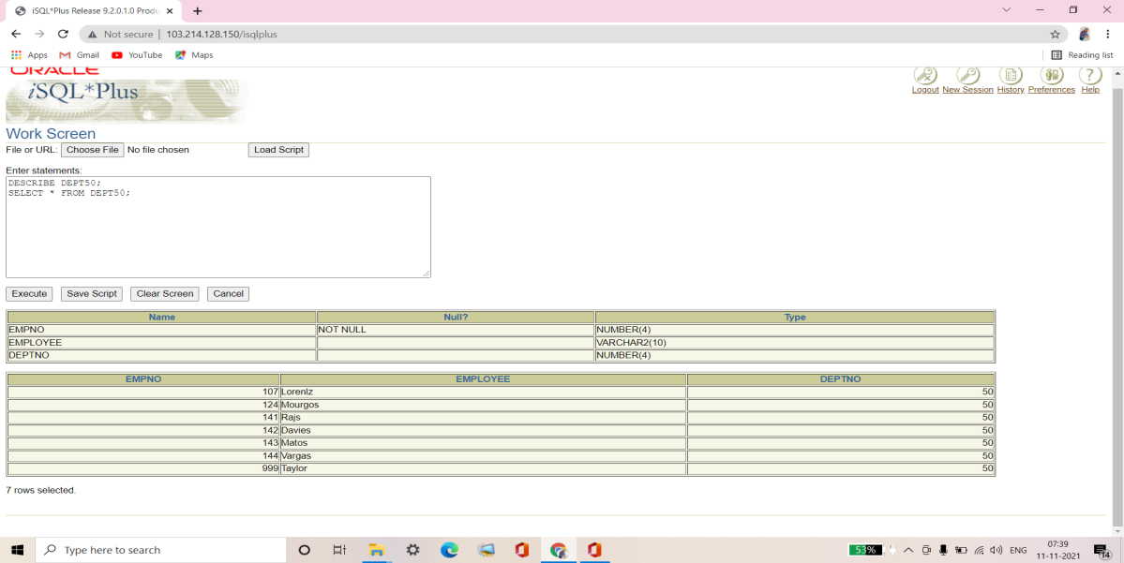

**Q7. Attempt to reassign Matos to department 80.**

Ans7.

UPDATE DEPT50

SET DEPTNO=80

WHERE EMPLOYEE = 'MATOS';

**Verification table-**

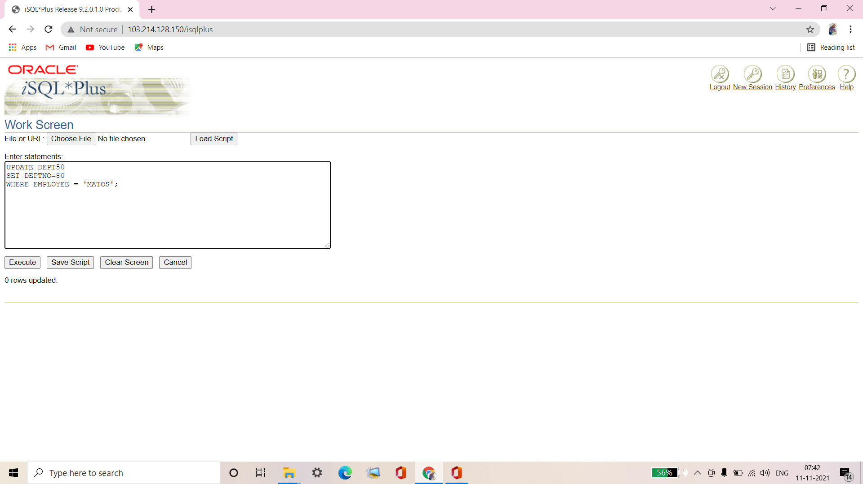

**If you have time, complete the following exercise:**

**Q8. Create a view called SALARY_VU based on the employee last names, department names, salaries, and salary grades for all employees. Use the EMPLOYEES, DEPARTMENTS, and JOB_GRADES tables. Label the columns Employee, Department, Salary, and Grade, respectively.**

Ans8.

CREATE OR REPLACE VIEW SALARY_VU AS

SELECT e.LAST_NAME "Employee", d.DEPARTMENT_NAME "Department",

e.SALARY "Salary", j.GRADE_LEVEL "Grades"

FROM EMPLOYEES e, DEPARTMENTS d, JOB_GRADES j

WHERE e.DEPARTMENT_ID = d.DEPARTMENT_ID

AND e.SALARY BETWEEN j.LOWEST_SAL AND j.HIGHEST_SAL;

**Verification table-**

